**No-Code Deployment of Rancher Kubernetes on AWS GovCloud**

*By:* [*Zack Brady*](mailto:zack.brady@rancherfederal.com?subject=Intel%20News) *&* [*Andy Clemenko*](mailto:andy.clemenko@rancherfederal.com?subject=Intel%20News)*, Field Engineers – Rancher Government Solutions*

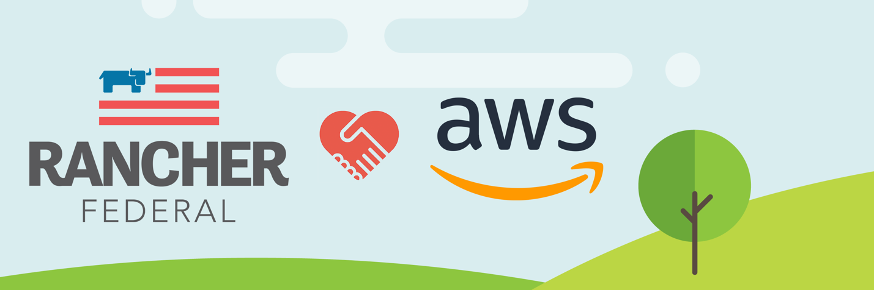

**Table of Contents**

* [Introduction](https://github.com/zackbradys/rancher-on-aws#introduction)
* [Challenges with Kubernetes](https://github.com/zackbradys/rancher-on-aws#challenges-with-kubernetes)
* [Why Rancher on AWS](https://github.com/zackbradys/rancher-on-aws#why-rancher-on-aws)
* [No-Code Deployment](https://github.com/zackbradys/rancher-on-aws#no-code-deployment)
* [Cloud Native Options](https://github.com/zackbradys/rancher-on-aws#cloud-native-options)
* [What's Next?](https://github.com/zackbradys/rancher-on-aws#what-s-next-)

**Introduction**

Over the last few years, Kubernetes has revolutionized the world of infrastructure and application distribution. From bare-metal servers to virtual machines to containers, Kubernetes has compelled teams to re-evaluate their entire technology stack – *in the very best way possible*. However, for many teams, Kubernetes is seen as a tall mountain to climb. But it doesn’t have to be.

You can perform no-code deployment of Rancher Kubernetes on the AWS Cloud.

**Kubernetes: Complexity with Opportunity**

Most teams start off in the world of clusters and containers and are surprised by the level of complexity of the configuration, management, and deployment involved. From service meshes to ingress controllers to registries and more, there is a lot to consider and to get right. OpsRamp has a great [chapter](https://www.opsramp.com/guides/why-kubernetes/challenges-with-kubernetes/) on this. Teams can become overwhelmed and exploring open-source tools, enterprise tools, or start diving down the deep dark path of internal development.

Thankfully there are many managed Kubernetes or Kubernetes-as-a-Service offerings. As an industry, we are seeing a continual and growing shift away from self-managed Kubernetes to managed Kubernetes. In these scenarios, Kubernetes is much easier to implement and manage.

If this is the path you’re taking, one thing to think about is the skillset needed to deploy an identical Kubernetes cluster at the edge, in the cloud, or in air gapped environments. The ability to have a flexible deployment module is very valuable for these types of scenarios.

Another thing to consider is your temporary, development, or test clusters. Being able to rapidly prototype an on-premise cluster in the cloud can greatly improve velocity for every team. A third thing to think about is vendor requirements and lock-ins. Some of the cloud providers charge to get your data out.

Teams looking to have the best of both worlds – a managed Kubernetes distribution with the in-house talent, the ability to quickly prototype, and no vendor lock-in – consider deploying a Kubernetes distribution one that you can take anywhere and everywhere – to a cloud environment.

**Why Rancher on AWS**

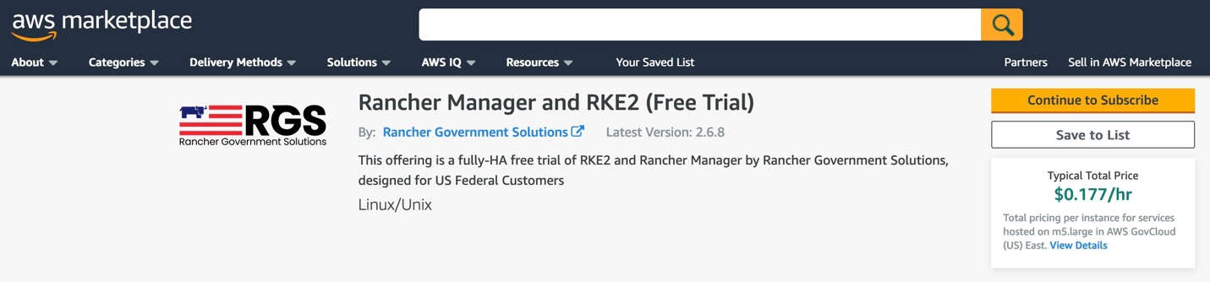

Rancher is rapidly becoming the Kubernetes of choice for every agency, company, and team because the Rancher stack has some exceptional choices for all the different layers of infrastructure.

Rancher, as a stack, is completely malleable. Meaning, you can pick and choose which piece you want to run when and where. This gives greater flexibility to engineering the right infrastructure at the right time for the right location. We have deployments from every cloud provider down to the tactical edge.

In addition, the Rancher stack is open source, this is important for better transparency for security and code quality. Sounds good, right? How about a "No-Code" deployment of the stack?

[Rancher Government Solutions](https://ranchergovernment.com/) (RGS) worked with [AWS](https://aws.amazon.com/) to develop a marketplace offering to dramatically reduce the barrier to entry. The offering is a highly available free trial of RKE2 and Rancher Manager by Rancher Government Solutions ([RGS](https://ranchergovernment.com/)), designed for U.S. Federal and Public Sector Customers.

**No-Code Deployment**

Seriously. It's zero code, zero configuration, and zero hassle. But what doyou get?

* Rancher Kubernetes Engine ([RKE2](https://www.rancher.com/products/rke)), which is a fully CNCF conformant Kubernetes distribution, focusing on security and compliance within the government and public sectors.
* Rancher Multi-Cluster Manager ([MCM](https://www.rancher.com/products/rancher)), which is the leading open-source platform for running Kubernetes in any environment, with over one billion in total downloads.
* For Amazon AWS... Virtual Private Cloud ([VPC](https://aws.amazon.com/vpc/)), Elastic Compute ([EC2](https://aws.amazon.com/ecs/)), Elastic Load Balancer ([ELB](https://aws.amazon.com/elasticloadbalancing/)), Route 53 ([DNS](https://aws.amazon.com/route53/)), Identity Access Management ([IAM](https://aws.amazon.com/iam/)), and Auto Scaling ([AS](https://aws.amazon.com/autoscaling/)).

Here is an architecture overview of the deployment:

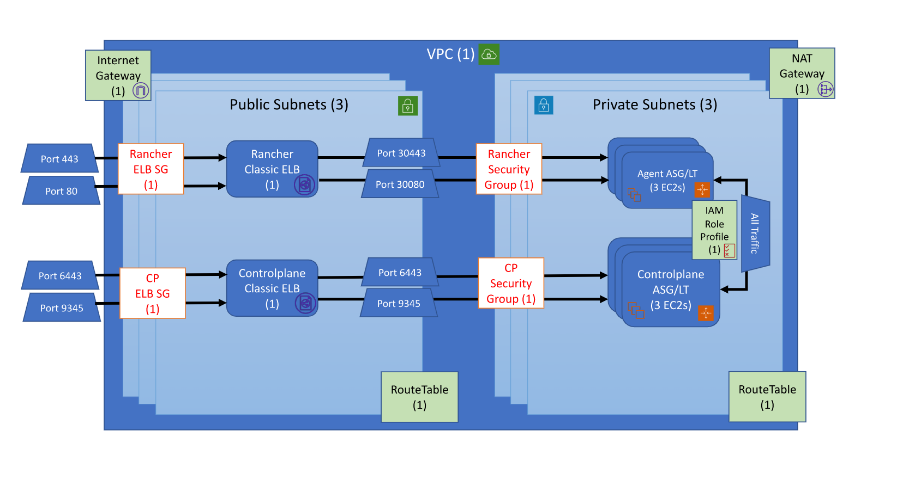

There are a few options and variables you need to set, but behind the scenes, it's an Amazon AWS Cloud Formation ([CF](https://aws.amazon.com/cloudformation/)) template. Currently, it's available at [**http://tryranchergov.com**](http://tryranchergov.com/) and ready to deploy in the Amazon AWS GovCloud ([US](https://aws.amazon.com/govcloud-us/?whats-new-ess.sort-by=item.additionalFields.postDateTime&whats-new-ess.sort-order=desc)) regions of **us-gov-east-1** and **us-gov-west-1**.

Let's walk through the steps.

* Click "Continue to Subscribe"
* Click "Accept the Terms"
* Click "Continue to Configuration"
* Select your options and regions. Click "Continue to Launch"
* Verify Options. Click "Launch"
* Signin to your AWS GovCloud Account.
* Enter all the AWS specific items, like keys, tokens, domain names and others.

Here's the complete process:

[**https://github.com/zackbradys/rancher-on-aws/blob/main/images/rancher-aws-setup.gif**](https://github.com/zackbradys/rancher-on-aws/blob/main/images/rancher-aws-setup.gif)

**A few moments later and with a handful of clicks...** you will have a fully deployed, configured, and highly available Rancher Kubernetes Cluster (RKE2) with Rancher Multi-Cluster Manager (MCM). There are endless reasons a low barrier to entry is important for teams.

Now that we have this deployed, let's take a look around!

The Rancher Manager has a ton of great features such as the application catalog and the continuous delivery tool known as Fleet. Fleet is a great way to integrate GitOPS into Kubernetes with no extra software and little effort!

Here's a quick overview:

[**https://github.com/zackbradys/rancher-on-aws/blob/main/images/rancher-aws-deployed.gif**](https://github.com/zackbradys/rancher-on-aws/blob/main/images/rancher-aws-deployed.gif)

**Cloud Native Options**

We understand there are alternatives out there. There are dozens of Kubernetes distributions and platforms in the Cloud Native Computing Foundation ([CNCF - Kubernetes](https://landscape.cncf.io/card-mode?category=certified-kubernetes-distribution&grouping=category)). It is a good idea to lean towards the open-source versions.

Clearly, there are some obvious leaders. When reviewing a managed Kubernetes solution, Amazon Elastic Kubernetes Service ([EKS](https://aws.amazon.com/eks/)) stands out as the best option. [AWS](https://aws.amazon.com/) has been a leader in the cloud ecosystem for years and years.

One clear advantage of using [Amazon EC2](https://aws.amazon.com/ecs/) with [Rancher](https://rancher.com/) over [Amazon EKS](https://aws.amazon.com/eks/), is that it is a virtual machine (VM) platform that provides redundancy with region specific datacenters and the Rancher Manager. This allows you to have a ton of flexibility to deploy what you need, where you need it.

**What's Next?**

After exploring the No-Code Deployment of the Rancher Stack, you can see there are a ton of options available to you. In our experience, the typical next steps start with deploying workloads (aka applications) and investigating infrastructure strategies. The Rancher Manager (MCM) has the application catalog to help in that journey. We would recommend deploying the "Monitoring Stack" as a great place to start. If you have existing clusters, the Rancher Manager (MCM) has the ability to leverage its features by importing those clusters.

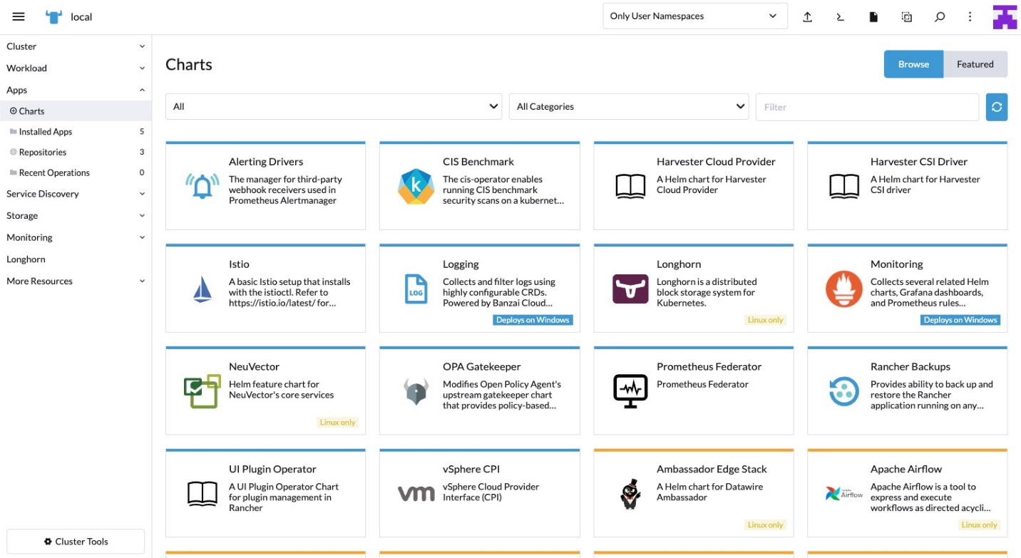

For investigating infrastructure strategies and exploring Kubernetes, the team at [RGS](https://ranchergovernment.com/)  is uniquely positioned to help your teams. RGS has the experience and history within the government and public sector and has been improving the security posture of the Rancher Stack for years. RGS also has the pleasure of guiding our government and public sector customers in deploying the Rancher Stack, anywhere and everywhere, leaving you to focus on your mission.

Combining [Amazon AWS](https://aws.amazon.com/) and [Rancher](https://rancher.com/), with the assistance of Rancher Government Solutions, creates a force multiplier. Please reach out to see how we can extend this experience to your missions and teams!